**Day 4**

**CE1:**

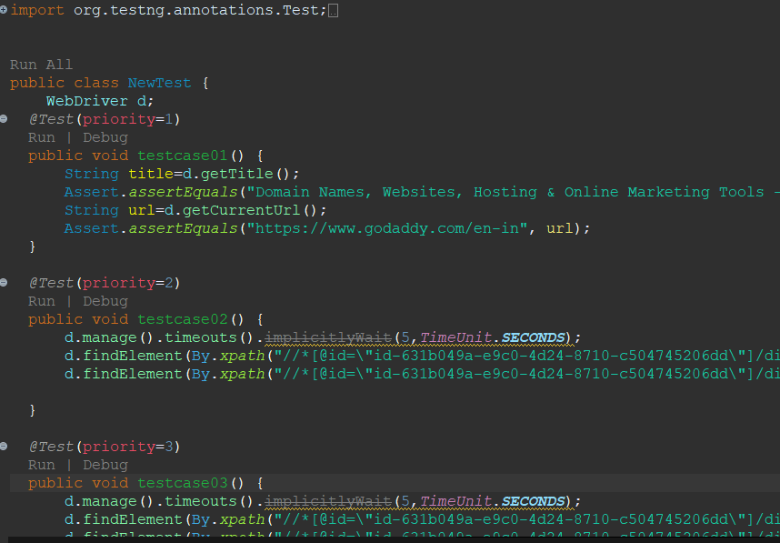

package com.Day5;

import org.openqa.selenium.By;

import org.openqa.selenium.WebDriver;

import org.openqa.selenium.WebElement;

import org.openqa.selenium.chrome.ChromeDriver;

import org.openqa.selenium.chrome.ChromeOptions;

import org.openqa.selenium.interactions.Actions;

import io.github.bonigarcia.wdm.WebDriverManager;

public class CE1 {

public static void main(String[] args) {

ChromeOptions co= new ChromeOptions();

co.addArguments("--remote-allow-origins=*");

WebDriverManager.chromedriver();

WebDriver d =new ChromeDriver(co);

d.get("https://demoqa.com/droppable/");

d.manage().window().maximize();

Actions a=new Actions(d);

WebElement source= d.findElement(By.id("draggable"));

WebElement destination=d.findElement(By.id("droppable"));

a.dragAndDrop(source, destination).build().perform();

}

}

**OUTPUT:**

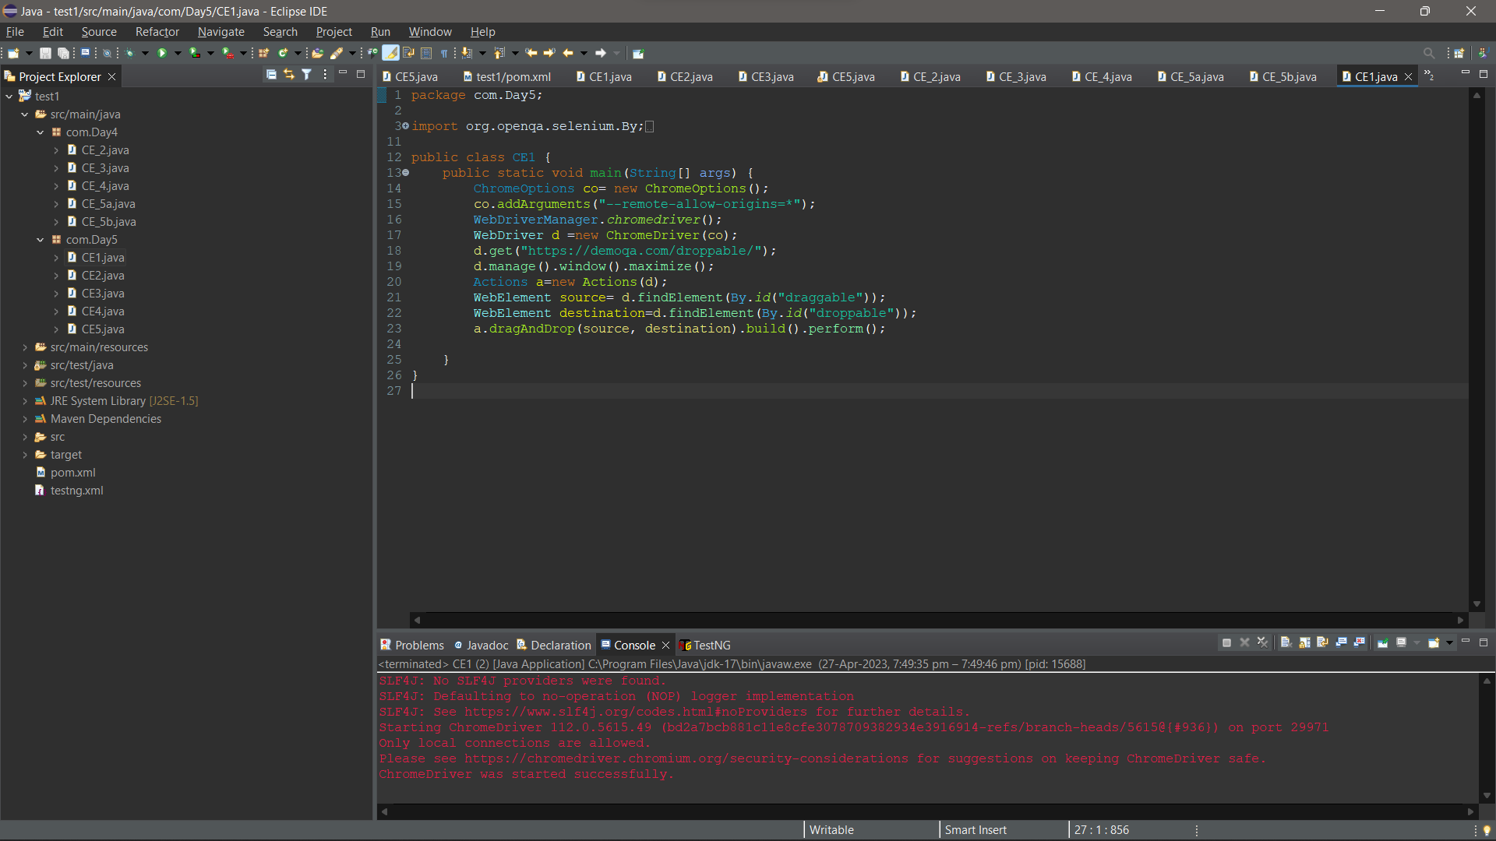

**CE2:**

package com.Day5;

import org.openqa.selenium.By;

import org.openqa.selenium.WebDriver;

import org.openqa.selenium.WebElement;

import org.openqa.selenium.chrome.ChromeDriver;

import org.openqa.selenium.chrome.ChromeOptions;

import org.openqa.selenium.interactions.Actions;

import io.github.bonigarcia.wdm.WebDriverManager;

public class CE2 {

public static void main(String[] args) {

// TODO Auto-generated method stub

ChromeOptions co= new ChromeOptions();

co.addArguments("--remote-allow-origins=*");

WebDriverManager.chromedriver();

WebDriver d =new ChromeDriver(co);

d.get("https://jqueryui.com/droppable/");

d.manage().window().maximize();

Actions a=new Actions(d);

d.switchTo().frame(0);

WebElement source= d.findElement(By.id("draggable"));

WebElement destination=d.findElement(By.id("droppable"));

a.dragAndDrop(source, destination).build().perform();

}

}

**OUTPUT:**

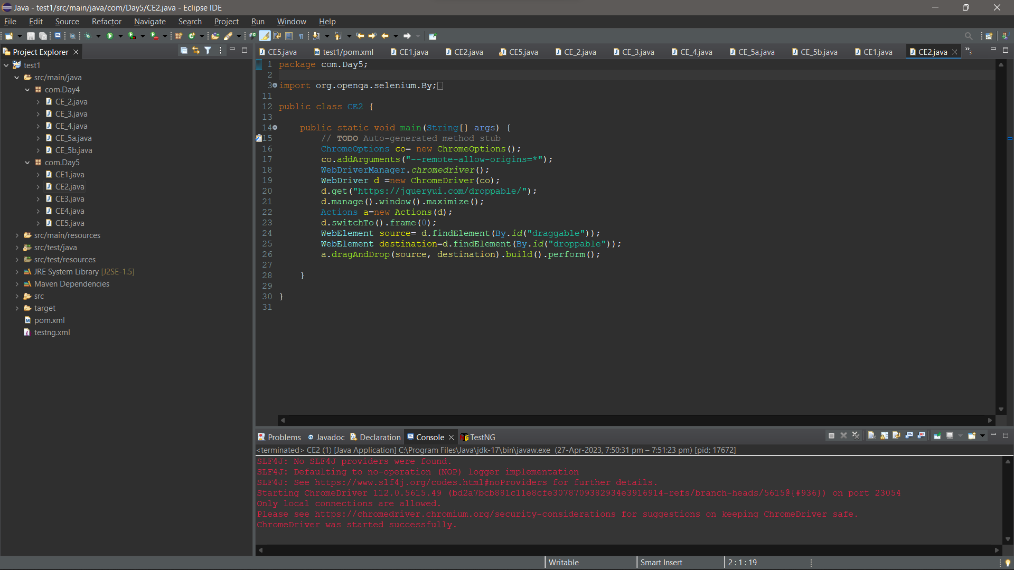

**CE3:**

package com.Day5;

import org.openqa.selenium.By;

import org.openqa.selenium.WebDriver;

import org.openqa.selenium.WebElement;

import org.openqa.selenium.chrome.ChromeDriver;

import org.openqa.selenium.chrome.ChromeOptions;

import io.github.bonigarcia.wdm.WebDriverManager;

public class CE3 {

public static void main(String[] args) {

// TODO Auto-generated method stub

ChromeOptions co= new ChromeOptions();

co.addArguments("--remote-allow-origins=*");

WebDriverManager.chromedriver();

WebDriver d =new ChromeDriver(co);

d.get("https://demo.guru99.com/test/delete_customer.php");

d.manage().window().maximize();

WebElement id=d.findElement(By.xpath("/html/body/form/table/tbody/tr[2]/td[2]/input"));

id.sendKeys("401");

d.findElement(By.xpath("/html/body/form/table/tbody/tr[3]/td[2]/input[1]")).click();

d.switchTo().alert().dismiss();

d.findElement(By.xpath("/html/body/form/table/tbody/tr[3]/td[2]/input[2]")).click();

WebElement id2=d.findElement(By.xpath("/html/body/form/table/tbody/tr[2]/td[2]/input"));

id2.sendKeys("402");

d.findElement(By.xpath("/html/body/form/table/tbody/tr[3]/td[2]/input[1]")).click();

d.switchTo().alert().accept();

String msg= d.switchTo().alert().getText();

System.out.println(msg);

}

}

**OUTPUT:**

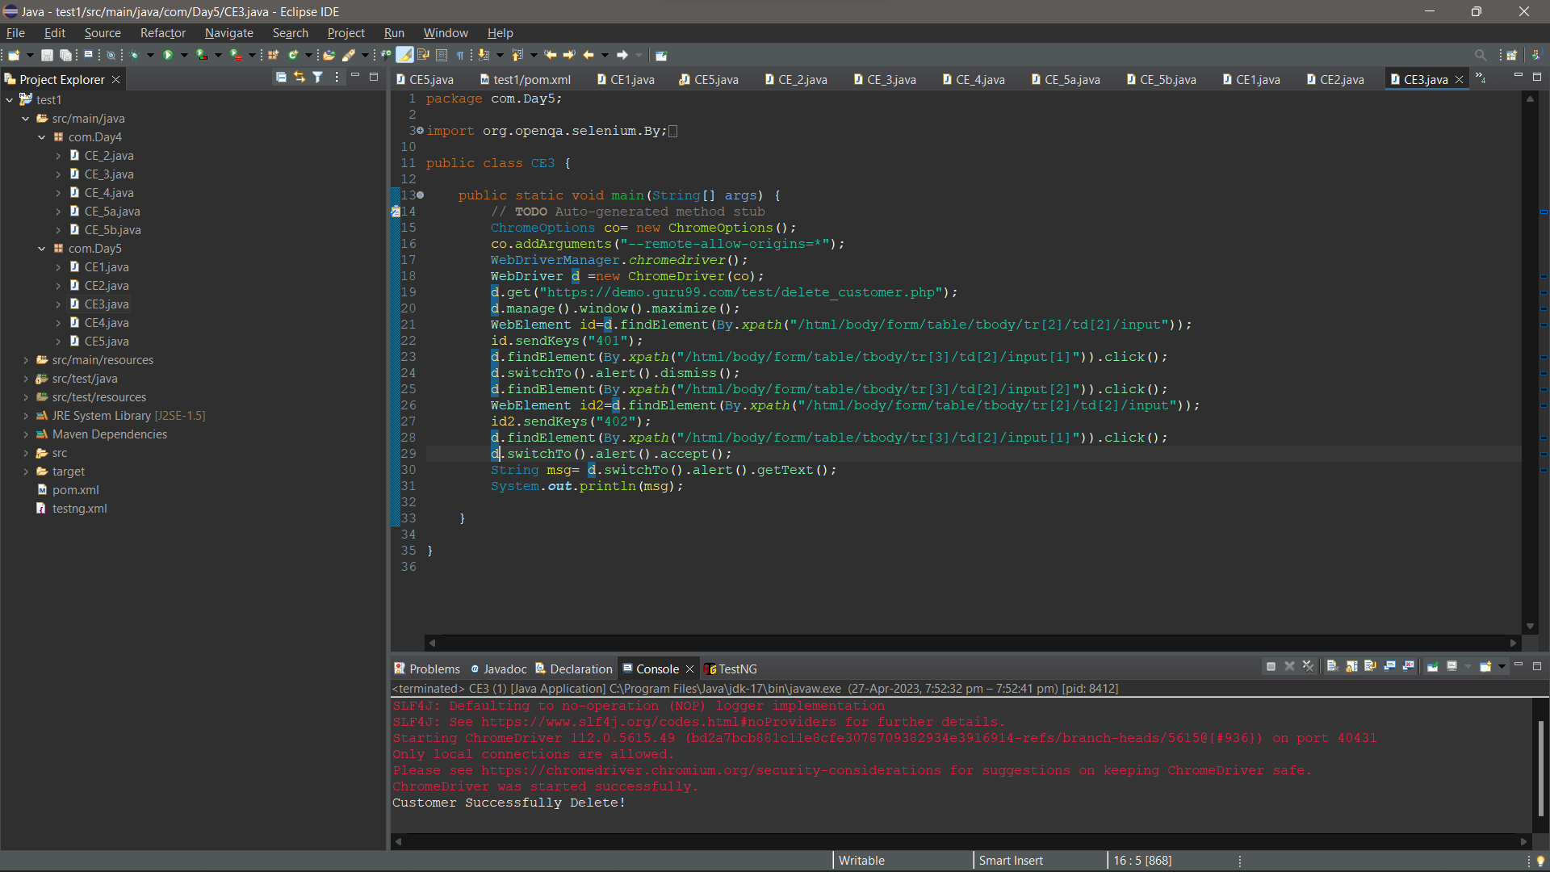

**CE4:**

package com.Day5;

import org.openqa.selenium.By;

import org.openqa.selenium.WebDriver;

import org.openqa.selenium.WebElement;

import org.openqa.selenium.chrome.ChromeDriver;

import org.openqa.selenium.chrome.ChromeOptions;

import io.github.bonigarcia.wdm.WebDriverManager;

public class CE4 {

public static void main(String[] args) {

// TODO Auto-generated method stub

ChromeOptions co= new ChromeOptions();

co.addArguments("--remote-allow-origins=*");

WebDriverManager.chromedriver();

WebDriver d =new ChromeDriver(co);

d.get("https://www.abhibus.com/bus-ticket-booking");

d.manage().window().maximize();

WebElement from=d.findElement(By.xpath("//*[@id=\"source\"]"));

from.sendKeys("Madurai");

WebElement to=d.findElement(By.xpath("//*[@id=\"destination\"]"));

to.sendKeys("Chennai");

d.findElement(By.xpath("//*[@id=\"datepicker1\"]")).click();

d.findElement(By.xpath("//*[@id=\"ui-datepicker-div\"]/div[2]/table/tbody/tr[4]/td[2]/a")).click();

d.findElement(By.xpath("//*[@id=\"seo_search_btn\"]")).click();

}

}

**OUTPUT:**

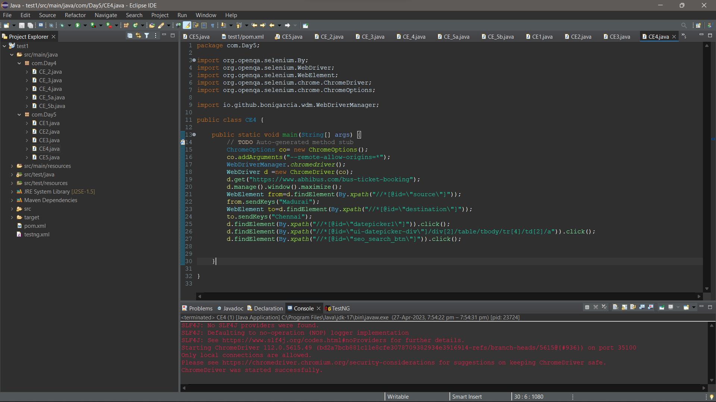

**CE5:**

package com.Day5;

import org.openqa.selenium.By;

import org.openqa.selenium.WebDriver;

import org.openqa.selenium.WebElement;

import org.openqa.selenium.chrome.ChromeDriver;

import org.openqa.selenium.chrome.ChromeOptions;

import org.openqa.selenium.edge.EdgeDriver;

import org.openqa.selenium.edge.EdgeOptions;

import io.github.bonigarcia.wdm.WebDriverManager;

public class CE5 {

public static void main(String[] args) {

// TODO Auto-generated method stub

ChromeOptions co= new ChromeOptions();

EdgeOptions co1=new EdgeOptions();

co.addArguments("--remote-allow-origins=*");

WebDriverManager.chromedriver();

WebDriverManager.edgedriver();

WebDriver d =new ChromeDriver(co);

d.get("https://www.google.com/");

d.manage().window().maximize();

WebElement s1=d.findElement(By.xpath("//*[@id=\"APjFqb\"]"));

s1.sendKeys("Apple");

d.findElement(By.xpath("/html/body/div[1]/div[3]/form/div[1]/div[1]/div[4]/center/input[1]")).click();

WebDriver d1 =new EdgeDriver(co1);

d1.get("https://www.google.com/");

d1.manage().window().maximize();

WebElement s2=d1.findElement(By.xpath("//*[@id=\"APjFqb\"]"));

s2.sendKeys("Selenium");

d1.findElement(By.xpath("/html/body/div[1]/div[3]/form/div[1]/div[1]/div[4]/center/input[1]")).click();

WebDriver d2 =new ChromeDriver(co);

d2.get("https://www.google.com/");

d2.manage().window().maximize();

WebElement s3=d2.findElement(By.xpath("//*[@id=\"APjFqb\"]"));

s3.sendKeys("Cucumber");

d2.findElement(By.xpath("/html/body/div[1]/div[3]/form/div[1]/div[1]/div[4]/center/input[1]")).click();

String id=d.getWindowHandle();

System.out.println(id);

String id1=d1.getWindowHandle();

System.out.println(id1);

String id2=d2.getWindowHandle();

System.out.println(id2);

String title=d.getTitle();

System.out.println(title);

String title1=d1.getTitle();

System.out.println(title1);

String title2=d2.getTitle();

System.out.println(title2);

}

}

**OUTPUT:**

